**TEST EVIDENCE – SPRING-3 - add 2 factor authentication and send OTP via mobile sms**

**Summary:**

Once the user provided username and password and if the credentials are valid, an OTP will be sent to the registered mobile number, with the help of which the user can access the user pages.

**STEPS followed:**

1. Created a free trial twilio account.
2. Registered my mobile no.
3. Made a note of account SID, account TOKEN , as they will be used in the project to initialize twilio.
4. Assigned a twilio no to myself.

**EXPECTATION:**

1. Once the user enters username and password, the application will validate it.
2. If the credentials are valid, then the application will generate a random OTP and send to the mobile no. registered to the user.
3. The application will also save the OTP in its DB.
4. Next the user will send request with username and OTP in its request headers.
5. The application will validate the OTP with the one present in DB. If the OTP matches, the /user page will be accessible.

**ACUTAL:**

1. Username password validation:

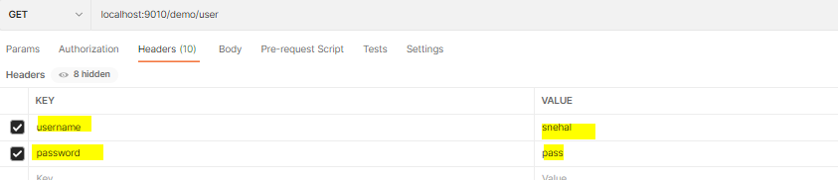



1. Send OTP to mobile no registered with the user.

OTP came to my mobile no. also in the response header:

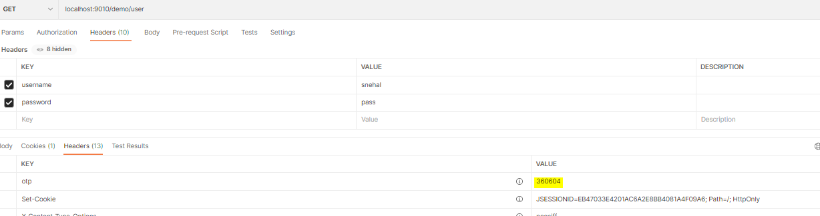

1. Application saved the OTP in its DB

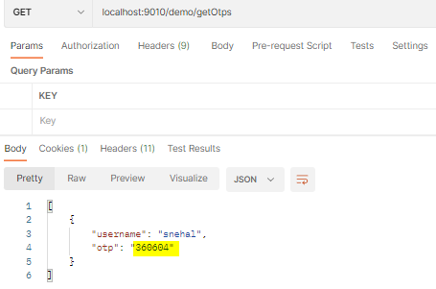

1. Request with username and OTP in headers:

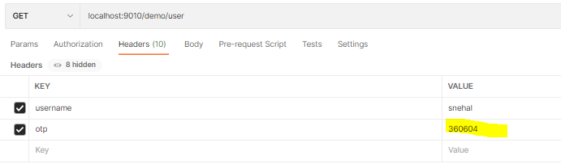

1. OTP validation:



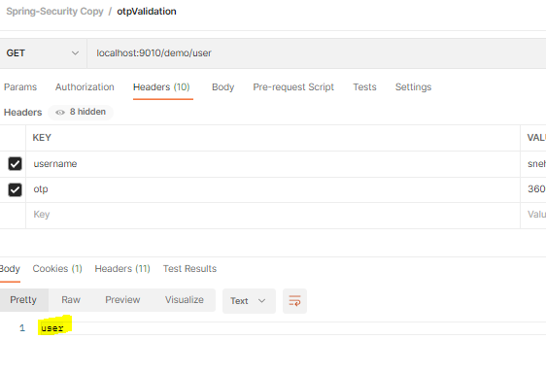

**COMMIT:**

**https://github.com/snehalwagh2121/SpringSecurityDemo/commit/d2755f23e49b5c4ec6c71d9b576b793a7fbe9778**